유스케이스

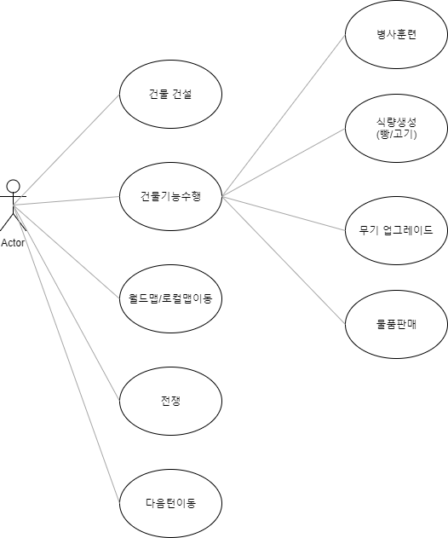

CD : ClassDiagram

클래스다이어그램

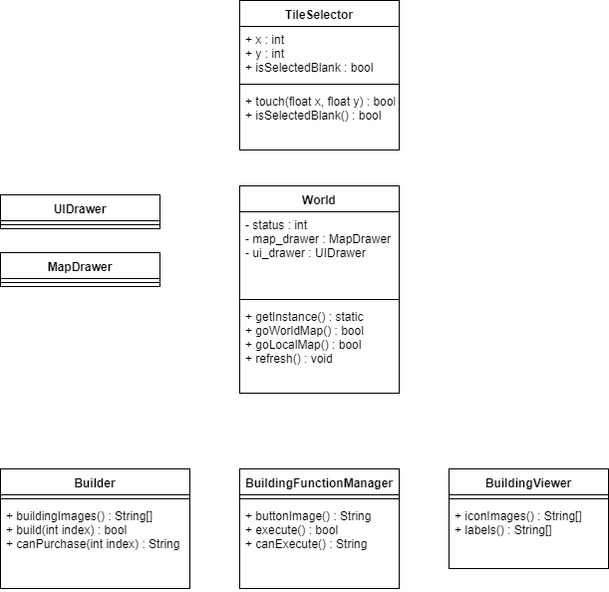

1. 건물 건설

1-1. 빈공간 선택

TileSelector(Class):isSelectedBlank ->(x,y) Building(DB, Dynamic)

TileSelector(Class):isSelectedBlank <-(bool) Building(DB, Dynamic)

UIDrawer(Class):DrawBuildingImages(CD수정필요) <- Builder(Class):buildingImages <-(image) Building(DB, Dynamic)

1-2. 원하는 건물 선택